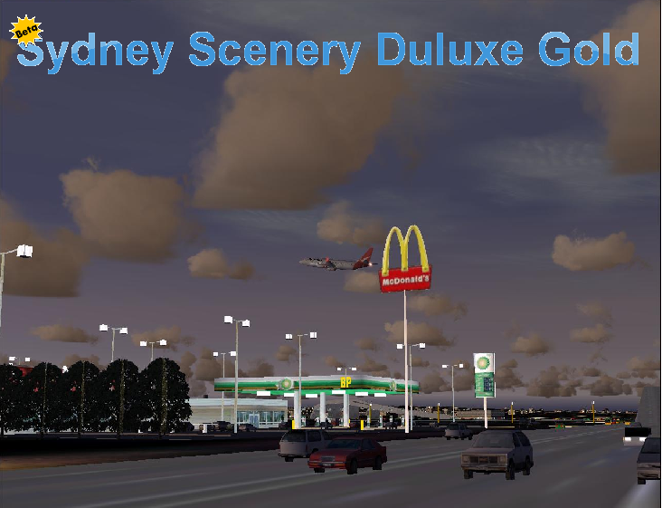

Copyright Notes

The author of this add-on (Jack McDonald) has copyrighted all material contained in this package. A majority of the items used are objects from libraries other authors have authorized me to use. If any of my package is taken apart or redistributed without the original .zip file you will have my lawyer as your new best friend.
By all means you may redistribute the .zip file and upload it to any website you may but all files must stay with eachother in that one .zip.

Thanks,
Jack McDonald
Ceo Of Duluxe Sceneries

WEBSITE: http://deluxe-sceneries.yolasite.com/
PLEASE DROP BY

Installation

To Install open the “ssdg_sydney_beta_gold.zip” and extract to a temporary folder on your hard drive. Double click on the SSDG YSSY.exe and follow the instructions on screen to install. At the end of installation it will prompt you to activate certain folders in FS2004.

That’s It!

Turning Off Certain Features Of

Where you downloaded the main .zip containing the files you will find on the same page a .zip called SSDG_Extras/Off. Download this file and you can replace certain BGLs to turn off certain fatures for reasons such as:

-Frame Rates Lag
-Computer Not Powerful Enough
-Drawing Problems
-ETC

What’s Included in
New and improved ground textures
Qantas with refurbished jetways
Qantas busses, pushback tugs and jetway signs
CityBank signs on side of qantas jetways
Qantas Skylounge on top of international terminal
New parking for Singapore Airlines A380 and Qantas A380
Loads of trees and bushes
New grass texture (photorealistic)
Re-designd AFCAD with all proper taxiway markings (including the bend at corners that expand to mke it easier for jets to turn)
All realife parking positions
DHL warehouse and parking spaces
Improved heliport with Channel 10 hangars and general hangars
Fire station with access road that connects to tarmac and main roads that surround the airport.
Sand patches at end of runways that head out to water
New taxiway textures
Static traffic all the way around the airport (when your airraft is moving their is so many crs it looks like they are moving!)
Road overpasses
Working traffic lights that change colour.
Newly designed jetways for domestic terminal
Qantas cargo area with aircraft crates and shipping containers
New long term carpark model
New international terminal parking model
surrounding roads of airport including- Qantas Drive, General Homes Drive etc (roads right around)
Sydney CBD reworked roads incuding:
New Harbour Bridge Lighting
AI floatplanes and Rose Bay Sea Port
Added buildings
New dock area with cruise ship and custom boat AI
Randomly moving boats around harbor
Static cars and vehicles scattered around Sydney
Reworked landclass and shorelines
Beaches along Sydney coastline enhanced including Bondi Beach!
Many More items

General Info about Sydney Scenery Deluxe.

Sydney scenery deluxe was originally thought up by me, Jack McDonald and I have worked bits and pieces of Sydney every now and then taking a look at reviews of commercial scenery such as ‘CLS Sydney’ and CLS Sydney Pro X’ and ‘Tyler Newport photoreal Sydney’ and have modeled similar models of objects using Gmax©. The main item that inspired me to create this freeware addon was the realism overall that FS9 could produce and the lack of the default scenery in Sydney (even though they took the time to photoreal it!).

Hardest Parts about Scenery Design
In all the objects I created for Sydney Scenery Deluxe I think the Mcdonalds and BP fuel station were the hardest to model and perfect. Getting the right textures for these objects was extremely difficult. ILS was pretty easy due to me being able to go into night mode in FS2004 and using EZ-Scenery by ABACUS to place the poles. Using AFCAD to design the sand at the end of the runways heading out to the water was very hard until I discovered the FSUIPC model. That made life a lot easier!

FREEWARE : FREEWARE : FREEWARE : FREEWARE : FREEWARE :

Copyright
Deluxe Sceneries JMC
All items and/or scenery objects contained in this package are the property of me or the rightful owner. Please feel free to upload this freeware to any site at all because I am only uploading it to my site http://deluxe-sceneries.yolasite.com . As I said this scenery may be uploaded to any server at all as long as all files remain un-edited and I receive a brief email telling me what server you wish to upload it to. Please send all emails to jacamaca88@hotmail.com

This is FREEWARE and no charges are to be made to the public:FREEWARE

Designer: Jack McDonald
Email: jacamca88@hotmail.com
FREEWARE : FREEWARE : FREEWARE : FREEWARE : FREEWARE :

Made For:
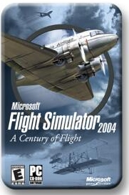

Screenshots:
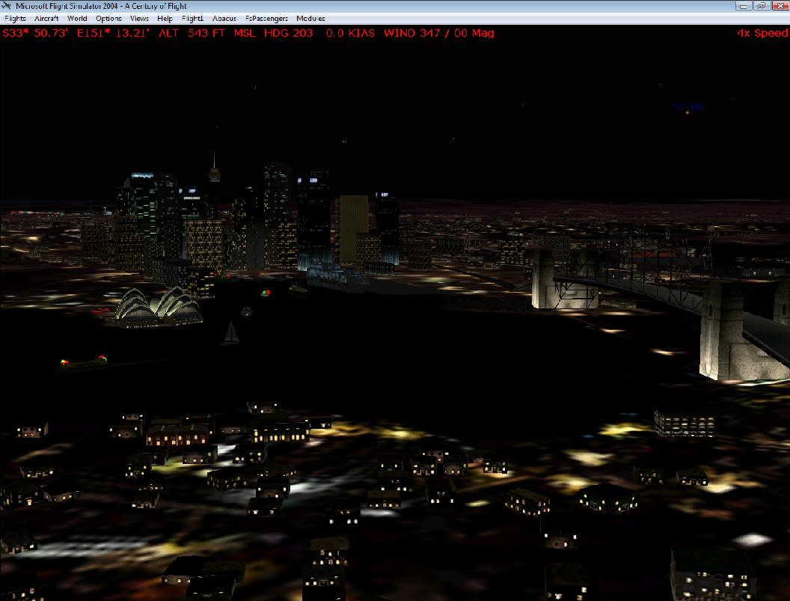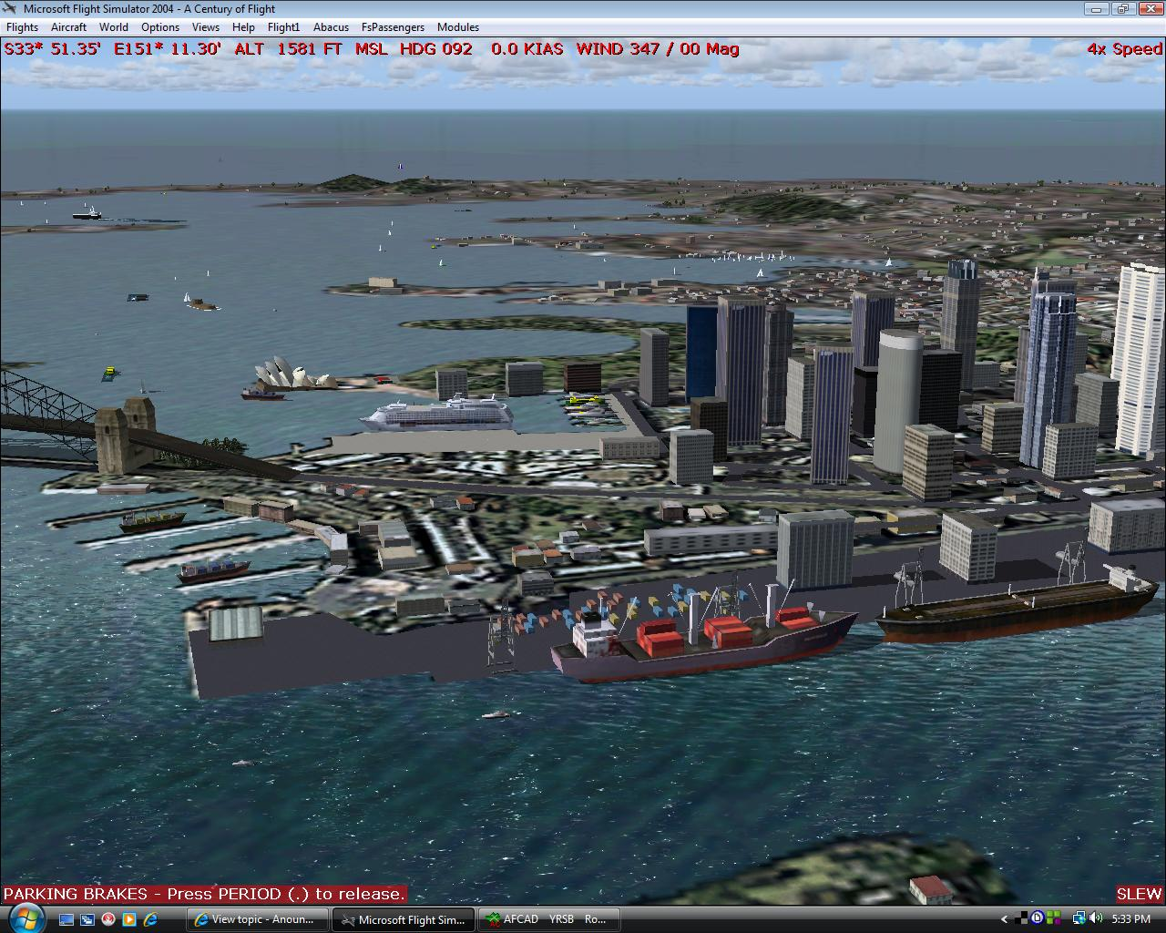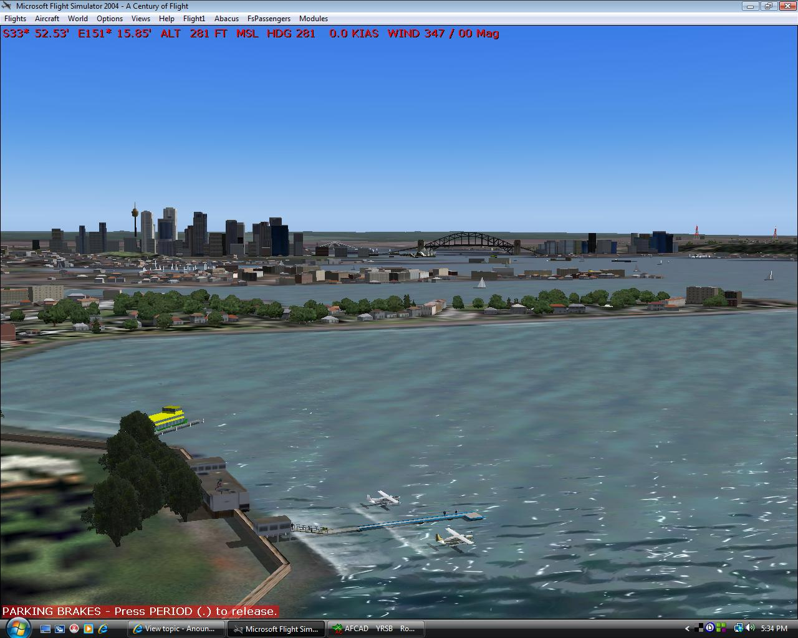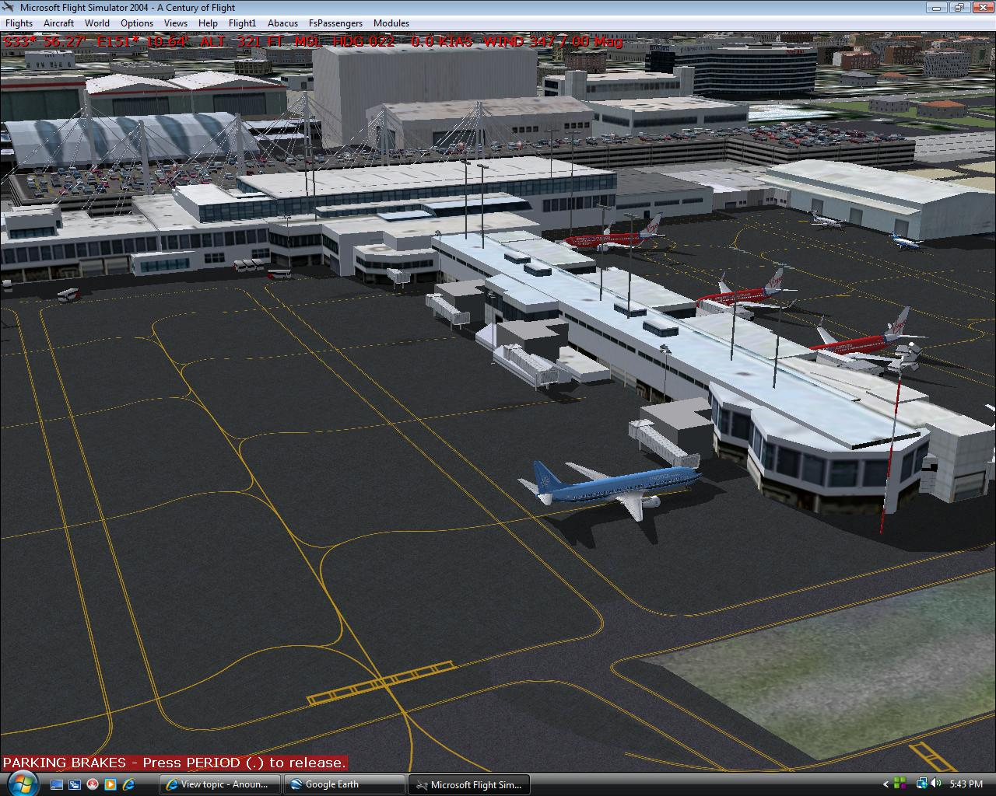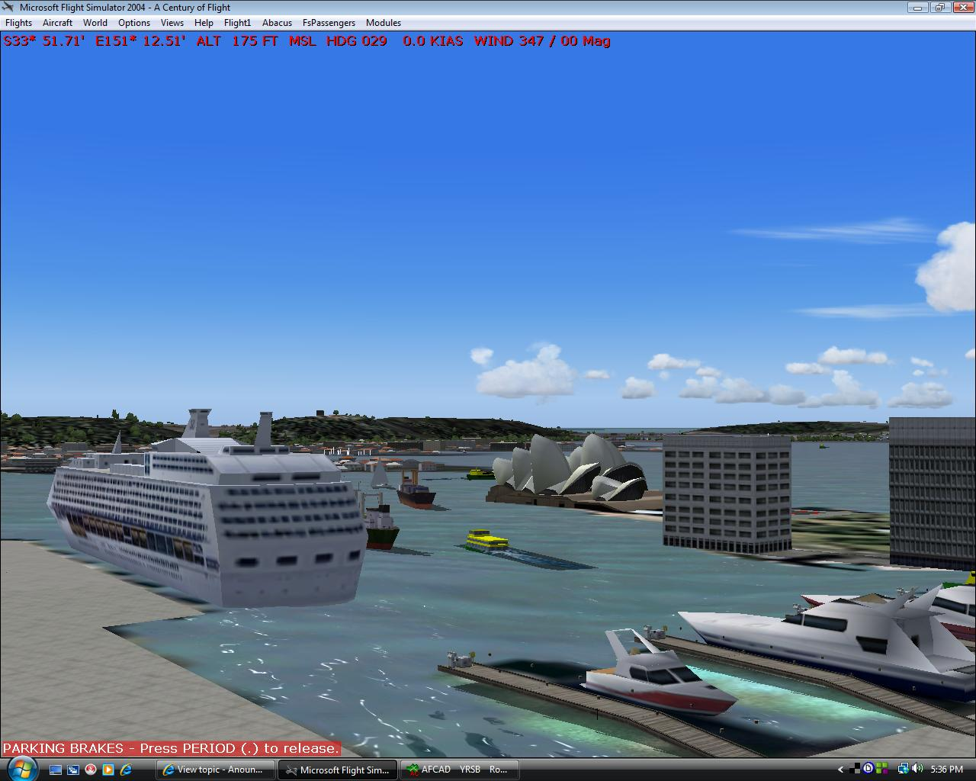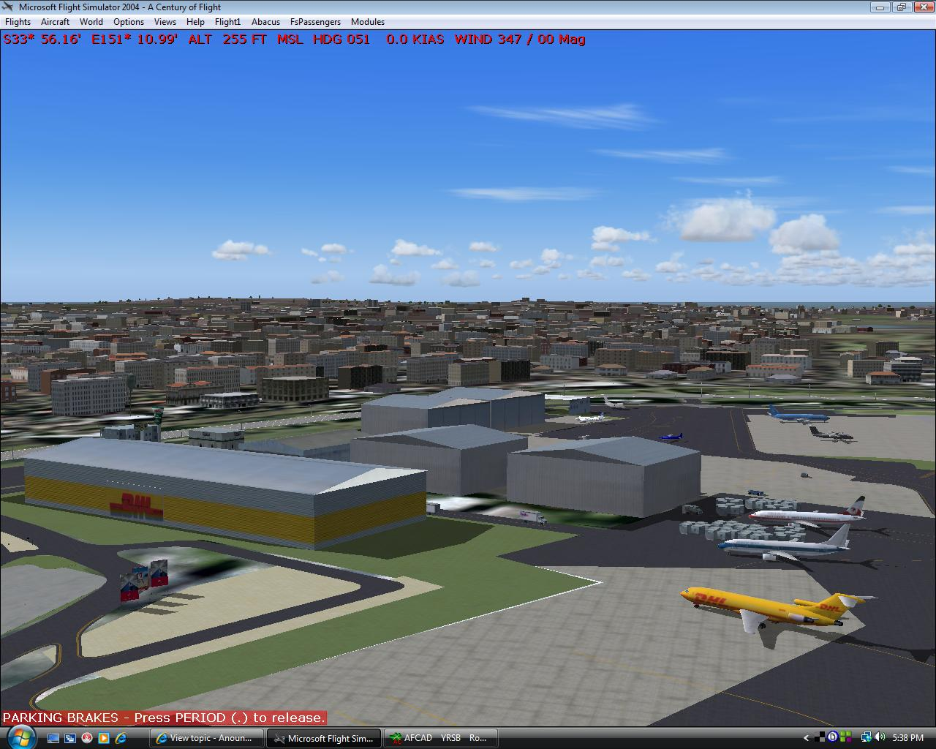

The End
By Jack McDonald

Sydney Scenery Deluxe Gold Beta Users Manual

